

**Additional Documentation**



Project Work 1

Jorge Hernández Gómez

June 2015

Functional requirements

* User login
* User registration
* Display contacts list
* Display chat room
* Send message
* Create chat group room
* Block users
* Report users

Mockups

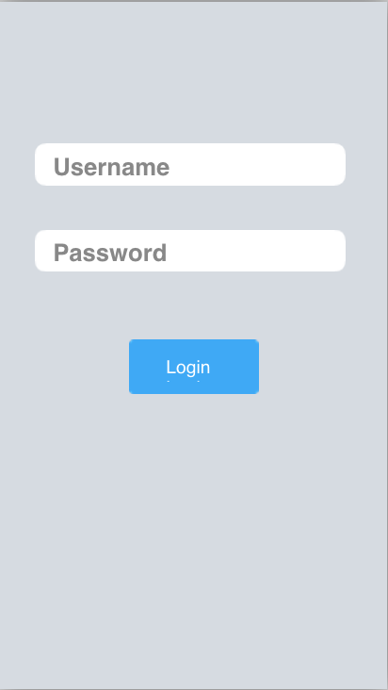 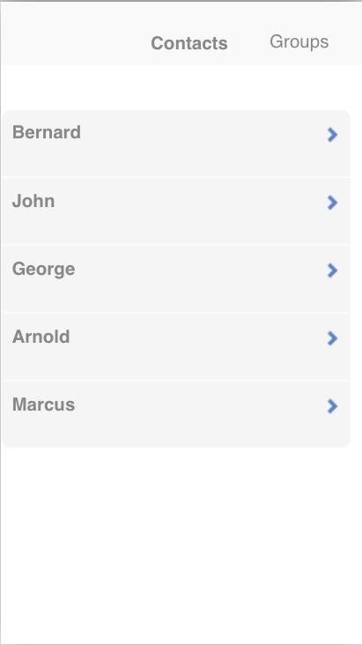

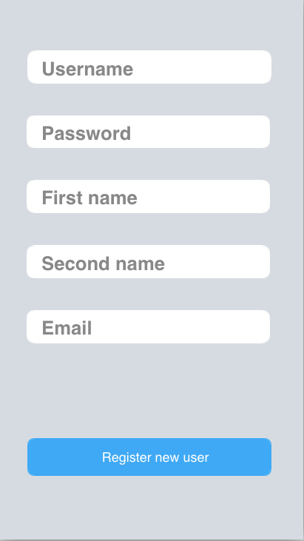 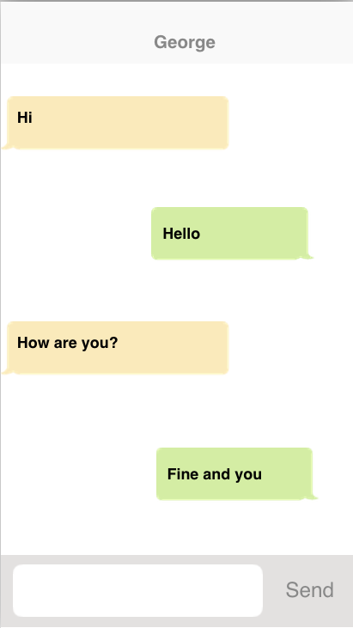

Chat tutorial references

<http://www.appcoda.com/chat-app-swift-tutorial/>

<https://maniacdev.com/2014/03/example-a-real-time-chat-app-complete-featuring-login-by-facebooktwitter>

<https://maniacdev.com/2012/04/tutorial-building-a-chat-application-easily-using-parse-com-for-the-backend>

Swift tutorials references

<http://www.raywenderlich.com/74438/swift-tutorial-a-quick-start>

<http://www.learnswift.tips/>

<http://www.tutorialspoint.com/swift/index.htm>

Chat server solutions references

<http://stackshare.io/stackups/firebase-vs-parse>

<http://stackshare.io/stackups/firebase-vs-socket-io>

<http://stackshare.io/stackups/parse-vs-socket-io>